Citizenship, Economics and Society (Secondary 1-3)
“3-minute Concept” Animated Video Clips Series:
“Diversity and Inclusiveness”
Teaching Guidelines

1. Title of the animated video clip: “Diversity and Inclusiveness”
2. Duration of the animated video clip: Around 3 minutes
3. Related CES Module (s): Module 1.2 Interpersonal Relationships and Social Inclusiveness, Module 1.4 Rights and Duties
4. Introduction of the animated video clip: The animated video clip was developed by the Personal, Social and Humanities Education Section, Curriculum Development Institute, Education Bureau. It uses daily examples and simple language to succinctly explain the concept of “Diversity and Inclusiveness”.
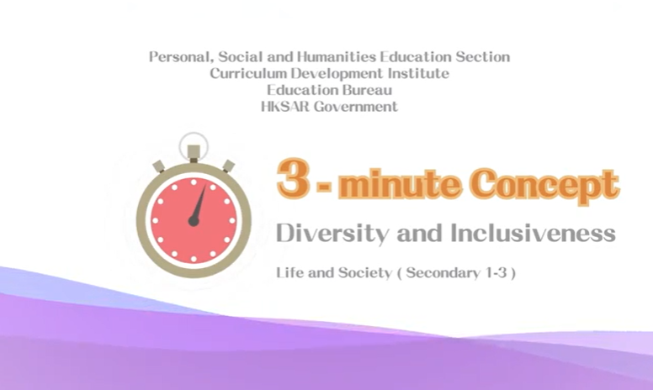
Citizenship, Economics and Society (Secondary 1-3)
Video link:
https://emm.edcity.hk/media/Life+and+Society+%223-minute+Concept%22+Animated+Video+Clips+SeriesA+%284%29+Diversity+and+Inclusiveness+%28English+subtitles+available%29/1_gn90uzt7
5. Teaching tips: Teachers must explain the following main points to students after playing the“Diversity and Inclusiveness” animated video clip:
1) Rights and duties are equally important | In teaching students to treat people of different backgrounds fairly and respect their rights in society, teachers must also point out that we should appreciate their contribution to society as well as encourage members of society to fufil their duties as Hong Kong residents. For the fundamental rights and duties of Hong Kong residents, please refer to the following webpage:  Basic Law Chapter III - Fundamental Rights and Duties of the Residents  https://www.basiclaw.gov.hk/en/basiclaw/chapter3.html
2) Policies on promoting “diversity and inclusiveness” put forward by the Government of the Hong Kong Special Administrative Region | Teachers should point out to students that the main focus of “diversity and inclusiveness” policies is that the Government is committed to building an inclusive society to enable everyone to enjoy equality and respect in different areas of life and receive assistance when needed, regardless of their backgrounds. The Government has provided a wide range of education, employment and other support services for people with disabilities, ethnic minorities, new arrivals and the underprivileged to help them integrate into the community. For the specific contents of “social inclusion” policies, please refer to the following resource:  GovHK - Embracing Social Inclusion https://www.gov.hk/en/residents/housing/socialservices/youth/SocialInclusion.htm  Teachers should point out to students that different members of society can contribute their strengths to building a diverse and inclusive society, which is a crucial factor contributing to the success of Hong Kong.
3) To achieve “diversity and inclusiveness” depends on the concerted effort of the community | Teachers should point out to students that apart from the Government, the private sector, voluntary organisations and individuals have different positive roles and responsibilities in promoting “diversity and inclusiveness”. Teachers are suggested to explain to students the social responsibilities and specific actions of the private sector in promoting inclusiveness; the advantages of voluntary organisations in promoting inclusiveness; and how individuals can fulfil their civic responsibilities and help build a diverse and inclusive society.
4) Beware of misunderstanding the concept of “diversity and inclusiveness” | Teachers should point out to students that “diversity and inclusiveness” policies focus on the Government’s commitment to building an inclusive society so that all individuals, regardless of backgrounds, can enjoy equality and receive assistance when needed. In short, providing fair opportunities and additional assistance is more important than stipulating equal outcomes for all. Teachers are suggested to explain to students that it is not appropriate to measure the effectiveness of “diversity and inclusiveness” policies solely based on attainment of equal outcomes. Teachers should point out to students that different members of society can play an active role in building a diverse and inclusive society. Everyone can participate in the development of society when society achieves diversity and inclusiveness. It is the factor contributing to the success of Hong Kong.
5) Opportunities for students to experience related real world situations is necessary for understanding “diversity and inclusiveness” | Teachers should point out to students that “diversity and inclusiveness” is an abstract concept. Students need to put themselves in related contexts in order to fully understand the essence of diversity and inclusiveness. Teachers are suggested to use contexts of school and society to guide students to develop an attitude of inclusiveness, acceptance and respect towards people with disabilities, ethnic minorities, new arrivals and the underprivileged. To let students understand that diversity and inclusiveness can help people respect the rights and responsibilities of others, thereby enhancing their sense of belonging to Hong Kong society and social cohesion, which will enable Hong Kong to develop in a more harmonious, stable and dynamic manner.

6. Consolidation questions: (See next page)

“3-minute Concept” Animated Video Clips Series:

“Diversity and Inclusiveness”

Worksheet

A. Fill-in-the-blank Questions
Put the correct answers in the space provided.
Society is made up of people from different backgrounds. Everyone will have the opportunity to participate in the development of society, utilise their strengths and contribute to building a diverse and inclusive society if we can

accept
respect
include

treat each other fairly
appreciate

B. True or False
Study the following sentences about “Diversity and Inclusiveness”. Put a “T” in the blank for correct description and an “F” for incorrect description.
 | The “Universal Declaration of Human Rights” has stipulated that all human beings are born free and equal in dignity and rights. | T
 | In a diverse and inclusive society, everyone can utilise their strengths and this helps develop a sense of belonging. | T
 | Diversified talents and opinions can help enhance creativity and competitiveness which are the driving forces of societal development. | T

C. Short Question
What kinds of systems and policies are the important foundation of a diverse and inclusive society?
Inclusive and caring systems and policies.

The End

